**Logical Operators and Booleans**

Comparsion Operators

* Comparison operators compare two values with one another.
* Return true/false

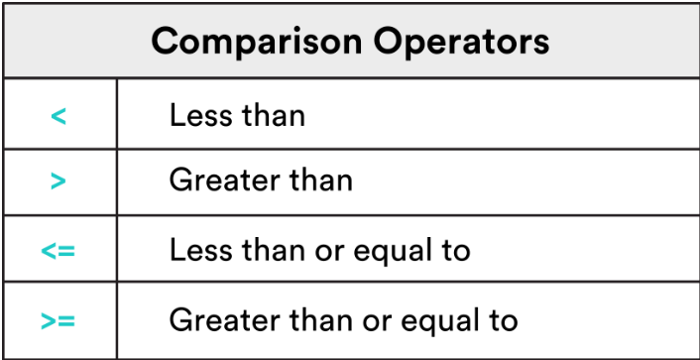

“===” is a strict comparison – JS compares both *type* and *value* .

“==” is a loose comparison – JS compares only the *value*.

When you declare a variable without assigning a value, the variable becomes undefined.

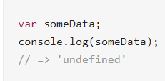

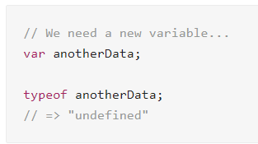

“undefined” is a datatype. When you use “typeof” to check the dataype, it shows “undefined”.

Null vs Undefined

* undefined is reserved for variables whose values *have not been set*.
* null is reserved for variables whose values are *explicitly nothing*.

** A null variable is a variable which is defined - as a variable without a value.

Truthy vs Falsey

Everything has an inherent Boolean value. ! is like a negative in math. Two negatives make a positive.

For example;

!”apple” = false

!!”apple” = true

|  |  |
| --- | --- |
| **Truthy** | **Falsey** |
| true | false |
| 6 (any non-zero number) | 0 (zero) |
| “apple”(any non-empty string) | empty string |
| Pretty much everything else | null and undefined |

Logical Operators

|  |  |
| --- | --- |
| Logical Operators | |
| && | and |
| || | or |
| ! | not |

For &&, only true && true evaluates to true!

For ||, only false||false evaluates to false!

Logical operators on numbers!

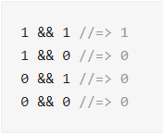

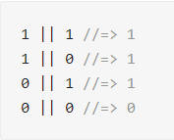

More example:

1 || "kiwi" //=> 1

"kiwi" || 1 //=> “kiwi”

**Conditionals**

Syntax

Syntax for if-else statements similar to Java.

***

if (condition) {action when true}

else {action when false}

***

If-else statements can be represented in a flow chart.

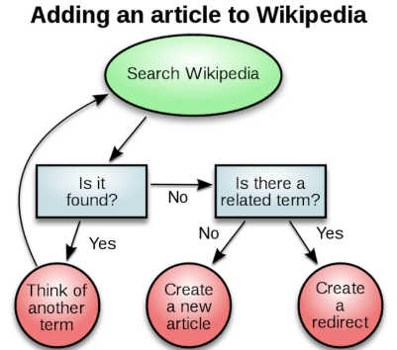

Else – if

We can use “else-if” for more complex logics in our program.

For example:

if (condition) {action when true}

else if {action when condition 1 fails}

else {action when condition 1 and 2 fails}

We can add as many “else-if” statements as we want.

Assignment Vs Comparison

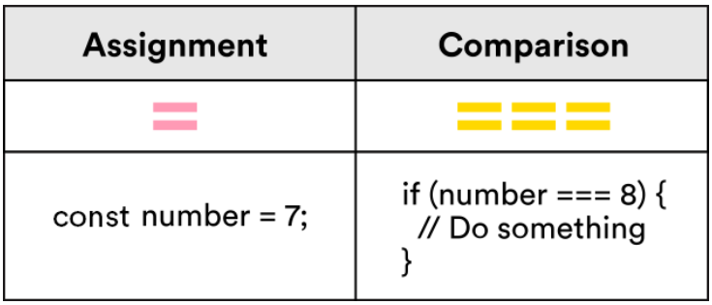

Switch and Ternary Operators

**SWITCH OPERATOR**

Switch statements allow complex conditionals to be expressed succintly. Compared to if-else statements, they are easier for humans to read and computer to process.

Here is an example of a switch statement:

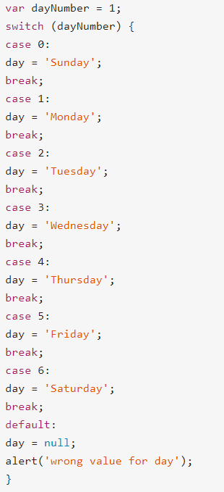

“break” is used to *break* out of the switch statement and execute the lines after it, when the case has been found and relevant action has been executed.

switch only works if you are testing the **same variable** (in the above example – the day of the week). It wouldn’t work if each condition is testing on different variables.

** When using a switch statement, make sure to define conditional and output variable.

** Make sure quotation marks are **straight**.

Example 1

var groceryItem = "orange";

var **price**;

switch (groceryItem) {

case "pear":

**price** = "The price is $1.00";

break;

case "apple":

**price** = "The price is $.65";

break;

case "orange":

**price** = "The price is $.80";

break;

case "avocado":

**price** = "The price is $1.50";

break;

case "grapes":

**price** = "Sorry, we are out of grapes";

break;

default:

**price** = "Item cannot be found in system";

}

Example 2

var favoriteMovie = "jaws";

var moviePhrase;

switch (favoriteMovie) {

case "jaws";

moviePhrase = "You're gonna need a bigger boat."

break;

case "the shining";

moviePhrase = "All work and no play makes Jack a dull boy."

break;

case "star wars";

moviePhrase = "Do. Or do not. There is no try."

break;

case "forrest gump";

moviePhrase = "Life was like a box of chocolates."

break;

case "back to the future";

moviePhrase = "Where we're going, we don't need roads."

break;

default:

moviePhrase = "Great movie choice!"

}

**TERNARY OPERATOR**

Ternary Operators is the shorthand for if-else statements.

Syntax:

condition ? resultIfTrue : resultIfFalse;

Example:

var isCoffeeReady = coffeeIsHot === true ? "Drink your hot coffee!" : "Time to brew a new batch.";

The above statement means –

if coffeeIsHot is true, var isCoffeeReady = "Drink your hot coffee!"

else, var isCoffeeReady = "Time to brew a new batch."

Another example:

var isMovieKidFriendly =(movieCategory === "scary" || movieCategory === "violent") ? "Pick a different movie." : "Movie is kid-friendly."